Experiment 1: rm, users, tree Commands

Aim
To execute and display the results of the rm, users, and tree commands in Kali Linux.

Procedure
- Open the Kali Linux terminal.
- Execute the users command to display the usernames currently logged in.
- Create a sample file using touch sample.txt.
- Execute rm sample.txt to remove the file.
- Execute the tree command to display the directory structure. If the command is unavailable, install it using sudo apt install tree.

Output
1. users command
┌──(kali㉿kali)-[~]
└─$ users
kali
Output may vary depending on logged-in users.
2. rm command
┌──(kali㉿kali)-[~]
└─$ touch sample.txt

┌──(kali㉿kali)-[~]
└─$ rm sample.txt

┌──(kali㉿kali)-[~]
└─$ ls sample.txt
ls: cannot access 'sample.txt': No such file or directory
3. tree command
┌──(kali㉿kali)-[~]
└─$ tree
.
├── Desktop
├── Documents
├── Downloads
└── Pictures

4 directories, 0 files
The directory names and counts shown above are examples.

Result
Thus, the rm, users, and tree commands were executed successfully in Kali Linux to remove files, display logged-in users, and view directory structures.
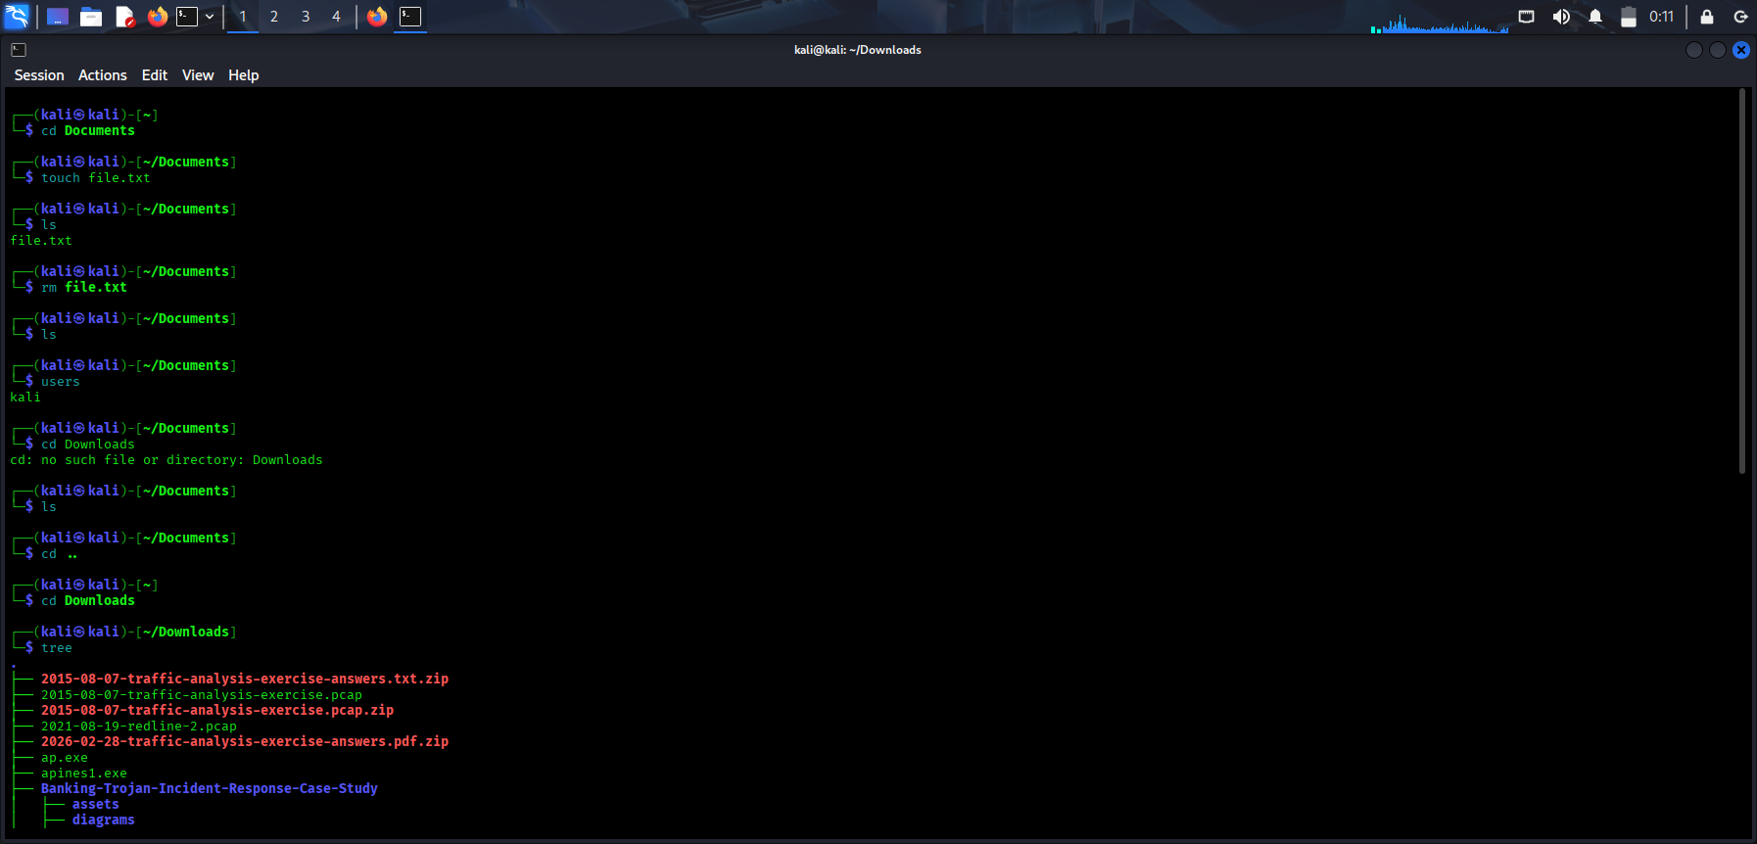

Experiment 2: less, more, vi Commands

Aim
To execute and display the results of the less, more, and vi commands in Kali Linux.

Procedure
- Open the terminal.
- Create a sample text file using nano sample.txt or cat.
- Execute less sample.txt to view the file contents page by page.
- Execute more sample.txt to display the contents one screen at a time.
- Execute vi sample.txt to open the file in the Vi text editor.
- Press q to exit less or more. In Vi, press Esc, type :q!, and press Enter to exit without saving changes.

Output
1. less command
$ cat > sample.txt
Welcome to Kali Linux
Ethical Hacking Lab
Linux Commands
Ctrl+D

$ less sample.txt
Welcome to Kali Linux
Ethical Hacking Lab
Linux Commands
2. more command
$ more sample.txt
Welcome to Kali Linux
Ethical Hacking Lab
Linux Commands
3. vi command
$ vi sample.txt
The Vi editor opens and displays the text in the file. Its appearance depends on the terminal and editor configuration.

Result
Thus, the less, more, and vi commands were executed to view text files page by page and open files using a text editor.
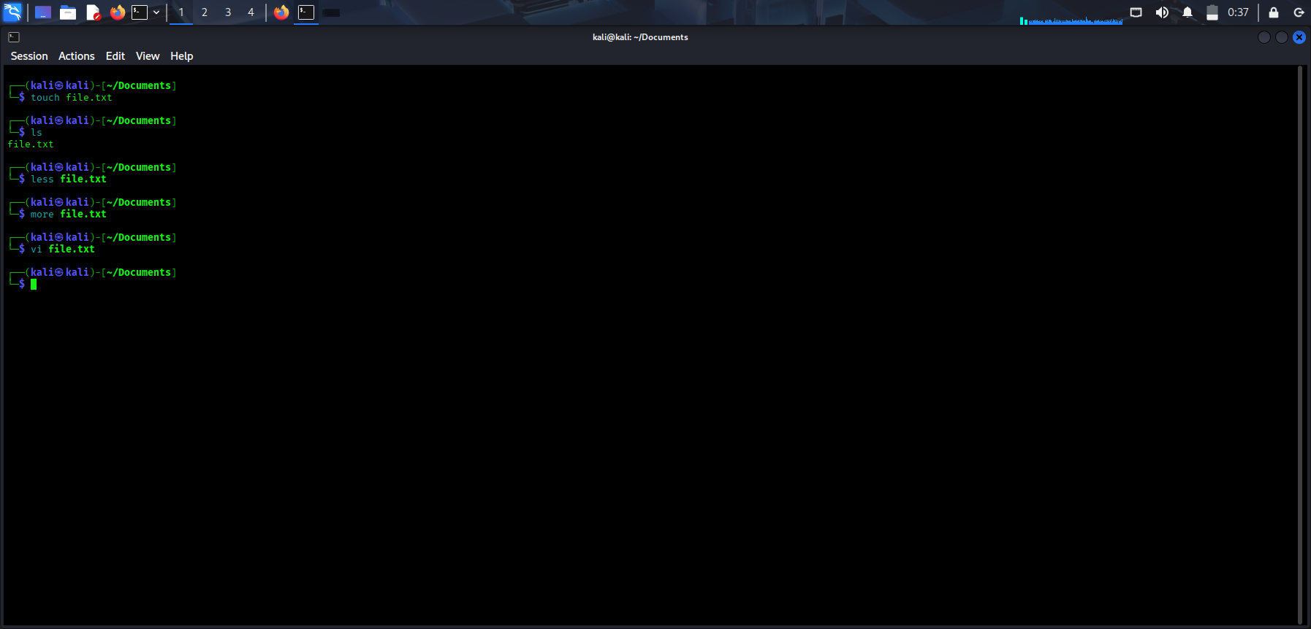

Experiment 3: tree, head, tail Commands

Aim
To execute and display the results of the tree, head, and tail commands in Kali Linux.

Procedure
- Open the terminal.
- Execute tree to display the directory structure.
- Create a sample file containing multiple lines.
- Execute head sample.txt to display the first ten lines by default.
- Execute tail sample.txt to display the last ten lines by default.

Output
1. tree command
$ tree
.
├── Documents
├── Downloads
└── sample.txt

2 directories, 1 file
2. head command
First, create a sample file:
$ seq 1 15 > sample.txt
$ head sample.txt
1
2
3
4
5
6
7
8
9
10
3. tail command
$ tail sample.txt
6
7
8
9
10
11
12
13
14
15

Result
Thus, the tree, head, and tail commands were executed to display directory structures, the beginning of a file, and the end of a file.
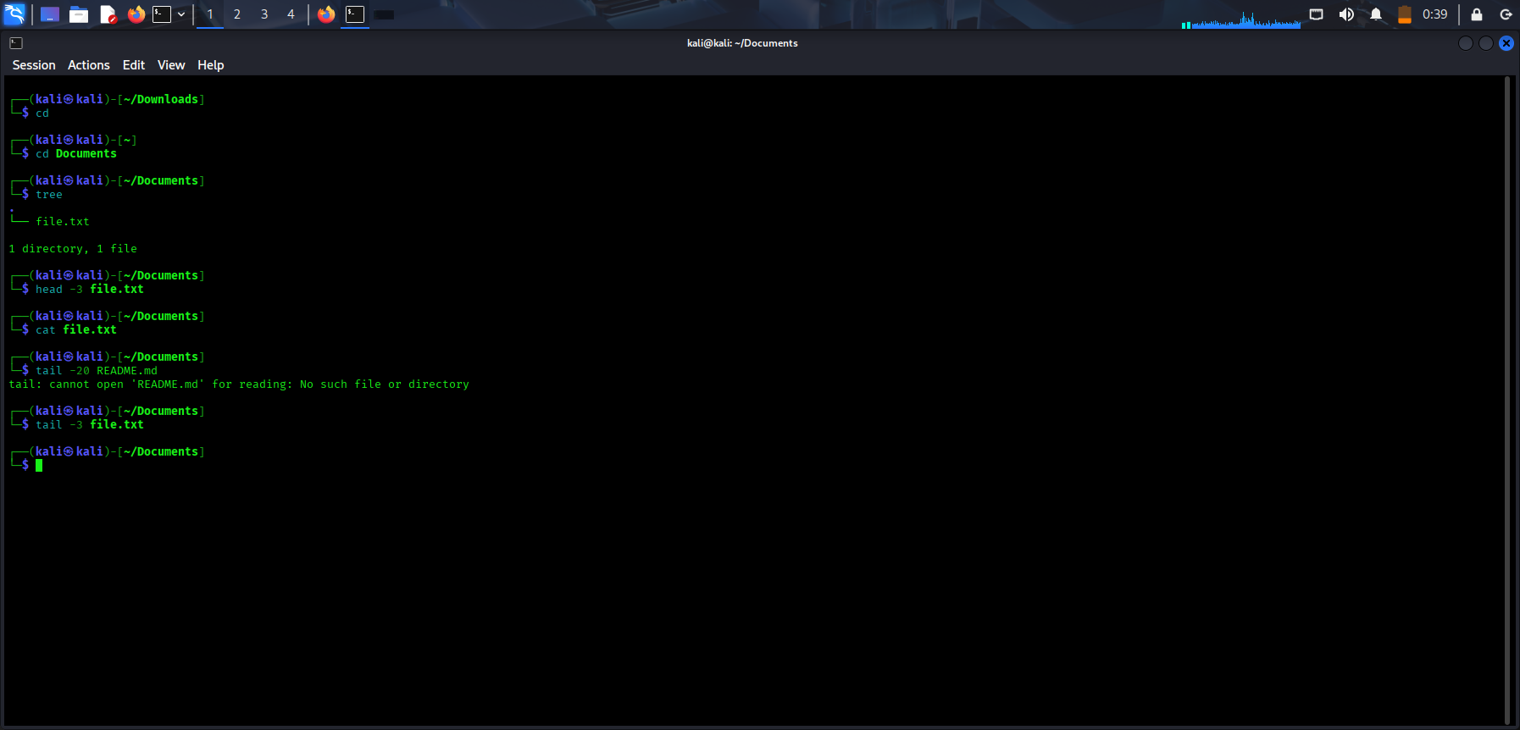

Experiment 4: ls, cat, mkdir Commands

Aim
To execute and display the results of the ls, cat, and mkdir commands in Kali Linux.

Procedure
- Open the terminal.
- Execute ls to list files and directories.
- Create a text file and enter some content using cat.
- Execute cat filename to display the file contents.
- Execute mkdir LabFolder to create a new directory.
- Execute ls again to verify that the directory was created.

Output
1. ls command
$ ls
Desktop Documents Downloads Music Pictures
2. cat command
$ cat > demo.txt
Ethical Hacking
Kali Linux Commands
Ctrl+D

$ cat demo.txt
Ethical Hacking
Kali Linux Commands
Press Ctrl + D after typing the content to finish creating the file.
3. mkdir command
$ mkdir LabFolder
$ ls
Desktop Documents Downloads LabFolder demo.txt

Result
Thus, the ls, cat, and mkdir commands were executed successfully to list files, display or create text-file content, and create directories.
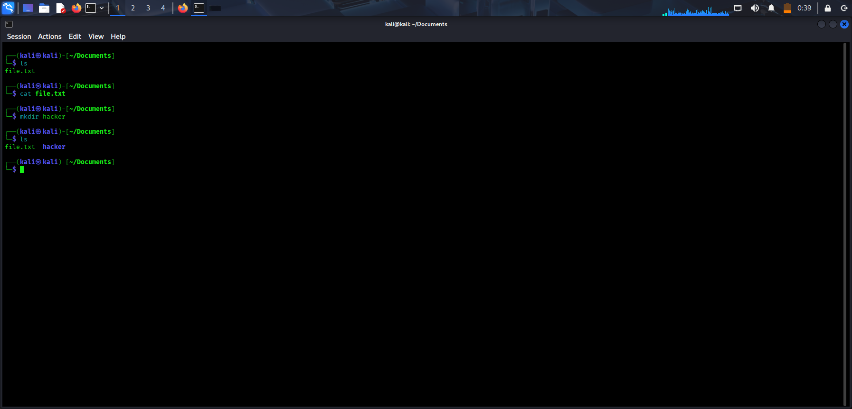

Experiment 5: uptime, date, mv Commands

Aim
To execute and display the results of the uptime, date, and mv commands in Kali Linux.

Procedure
- Open the terminal.
- Execute uptime to display the system's running time and load information.
- Execute date to display the current system date and time.
- Create a sample file using touch old.txt.
- Execute mv old.txt new.txt to rename the file.
- Use ls to verify the change.

Output
1. uptime command
$ uptime
15:00:00 up 2:15, 1 user, load average: 0.05, 0.03, 0.01
2. date command
$ date
Thu Oct 29 15:00:00 IST 2026
The time and date shown are illustrative; your output will show your system's current date and time.
3. mv command
$ touch old.txt
$ mv old.txt new.txt
$ ls new.txt
new.txt

Result
Thus, the uptime, date, and mv commands were executed to display system status, show the current date and time, and rename a file.
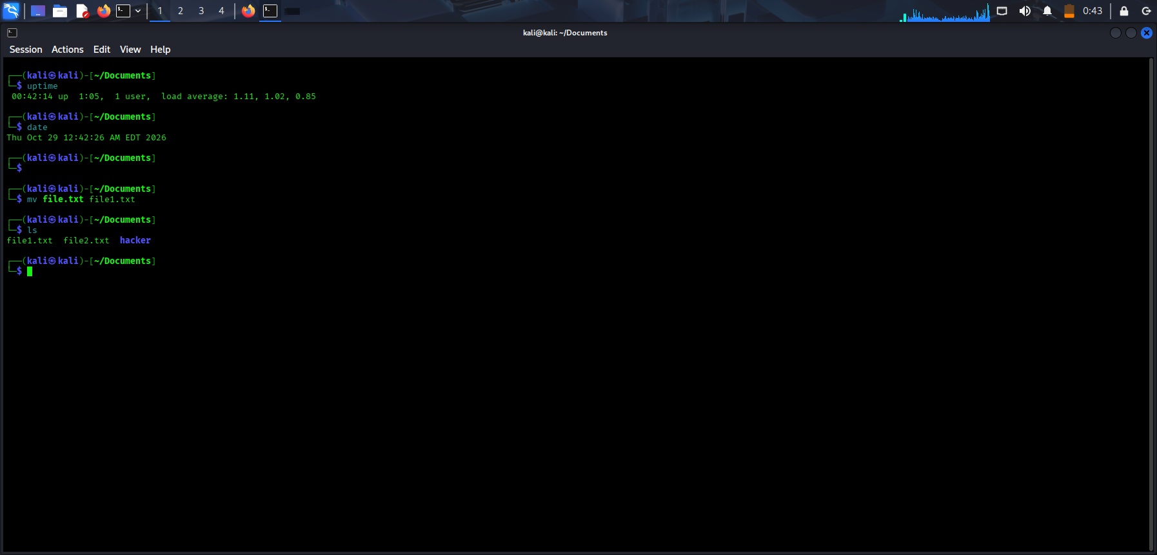

Experiment 6: touch, pwd, wget Commands

Aim
To execute and display the results of the touch, pwd, and wget commands in Kali Linux.

Procedure
- Open the terminal.
- Execute touch test.txt to create an empty file.
- Execute pwd to display the present working directory.
- Execute wget with a publicly accessible test URL to download a file.
- Use ls to verify the downloaded file.

Output
1. touch command
$ touch test.txt
$ ls test.txt
test.txt
2. pwd command
$ pwd
/home/kali
The path may differ depending on your current directory.
3. wget command
Download a small public test file:
$ wget https://www.w3.org/TR/PNG/iso_8859-1.txt
Example output:
--2026-10-29 15:00:00-- https://www.w3.org/TR/PNG/iso_8859-1.txt
Resolving www.w3.org...
Connecting to www.w3.org...
Saving to: 'iso_8859-1.txt'

iso_8859-1.txt saved
The exact download progress and completion message depend on the network connection and server response.

Result
Thus, the touch, pwd, and wget commands were executed to create files, display the current working directory, and download a file from the internet.
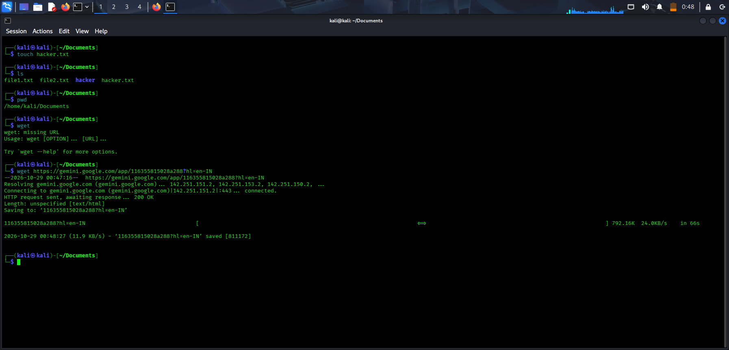

Experiment 7: cd, cp, ls Commands

Aim
To execute and display the results of the cd, cp, and ls commands in Kali Linux.

Procedure
- Open the terminal.
- Execute pwd to identify the current directory.
- Execute cd Documents to change to the Documents directory, if it exists.
- Execute cd .. to return to the parent directory.
- Create a sample file using touch original.txt.
- Execute cp original.txt copy.txt to copy the file.
- Execute ls to display and verify the files.

Output
1. cd command
$ pwd
/home/kali

$ cd Documents
$ pwd
/home/kali/Documents

$ cd ..
$ pwd
/home/kali
2. cp command
$ touch original.txt
$ cp original.txt copy.txt
$ ls
copy.txt original.txt
3. ls command
$ ls
Desktop Documents Downloads copy.txt original.txt
Your directory listing may be different.

Result
Thus, the cd, cp, and ls commands were executed successfully to change directories, copy files, and list directory contents.
